

Inspection and test plan – Concrete Blinding, Pile Caps and Slab Footings

**Project no.**  CC0398 **Project name**  VIVA ULSG **Date**  **13/12/2023 Approved by**  Ari Birch **ITP no.**  31 **Revision no.**  C **Revision date**  13/12/2023 **Plant and equipment used**  **Lot no.**  **Location (chainages, detailed description or marked up plan)**  **Layer thickness**  **Estimated qty**

Attach Dockets, Certificates and QA Documents to ITP

|  |  |  |  |  |  |  |  |  |  |  |
| --- | --- | --- | --- | --- | --- | --- | --- | --- | --- | --- |
|  | | | | | **Verification or test by** | | | | | **Remarks / record (eg. test frequency, reports, certificates, checklist**  **etc)** |
| **Symal Infrastructure** | | | **MDR/VIVA** | |
| **Item no.** | **Activity** | **Ref docs** | **Acceptance criteria** | **Acceptance** | **Key** | **Resp.** | **Initial/ date** | **Key** | **Sign date** |
| **Section A – Preliminaries and Blinding** | | | | | | | | | | |
| **1.0 General** | | | | | | | | | | |
|  |  |  | Has the mix design to be approved prior to placement. Material properties meet project specification, AS 3600, AS 1379? |  |  |  |  |  |  |  |
| **1.1** | Material Submission / Approval | AS 3600  235929-000- CV-SP-00007 | Do Structural Elements meet: Minimum Concrete strength 40 MPa or as specified in Drawings?  Do Non-Structural Elements meet: Minimum Concrete strength 15 MPa or as specified in Drawings?  Has Steel Reinforcement schedule provided to MDR for review and approved?  Do admixtures shall conform with AS 1478.1 and are permitted if used in accordance with manufacturers instructions? | * Yes ☐ No ☐ N/A | H | H | Mix Design Number  Bar Bending Schedules  Material compliance certificates |
|  |  |  | Mixtures containing calcium chloride shall not be used. |  |  |  |  |



**Commented [TR1]:** I would still add in a dashed line here to confirm the underlying lot number. This is not really for you on the sign off date, but rather for future reference where the reviewer may need to refer to the bulk earthworks lot. We need to be able to locate the underlying lot.

**Commented [DH2R1]:** Ok

|  |  |  |  |  |  |  |  |  |  |  |  |
| --- | --- | --- | --- | --- | --- | --- | --- | --- | --- | --- | --- |
|  | | | | | | **Verification or test by** | | | | | **Remarks / record (eg. test frequency, reports, certificates, checklist**  **etc)** |
| **Symal Infrastructure** | | | **MDR/VIVA** | |
| **Item no.** | **Activity** | **Ref docs** | | **Acceptance criteria** | **Acceptance** | **Key** | **Resp.** | **Initial/ date** | **Key** | **Sign date** |
| **1.2** | Determine lot size |  | | Lot Size = Each pour section per day (location or m2) or each structural (Pilecap) |  | S |  |  | S |  |  |
| **1.4** | Permits |  | | The following are relevant, in place and signed onto:   * Penetration permit * Hot works permit * Temporary work permit * Working at heights permit | * Yes ☐ No ☐ N/A | H |  |  | S |  |  |
| **2.0 Blinding/Lean Concrete** | | | | | | | | | | | |
| **2.1** | Set out | IFC drawings | | Extents, grades and levels correct to relevant drawings. All services have been marked out. | * Yes ☐ No ☐ N/A | W |  |  | W |  |  |
| **2.2** | Pre-Pour Inspection | Bulk Earthworks | | Has a pre-pour inspection been completed with the client, and they have verified in writing that the pour is able to commence?  The foundation base excavation shall be tested, surface compacted and approved prior to placement of the blinding. The foundation location,  depth and dimensions shall also be checked and confirmed prior. to placing the blinding. Approval |  |  |  |  |  |  | Pre-Pour Checklist  235929-000- CV-SP-00007 |
| ITP 02 |  |
| Underlying lot number: --------  ------------------- | | shall be provided, in writing, by McDermott to the  foundation. subcontractor before commencing with concrete placement.  Has this been completed? | * Yes ☐ No ☐ N/A | H |  |  | H |  | Appendix 7.1  Pre-Concrete Placement Checklist |



|  |  |  |  |  |  |  |  |  |  |  |
| --- | --- | --- | --- | --- | --- | --- | --- | --- | --- | --- |
|  | | | | | **Verification or test by** | | | | | **Remarks / record (eg. test frequency, reports, certificates, checklist**  **etc)** |
| **Symal Infrastructure** | | | **MDR/VIVA** | |
| **Item no.** | **Activity** | **Ref docs** | **Acceptance criteria** | **Acceptance** | **Key** | **Resp.** | **Initial/ date** | **Key** | **Sign date** |
| **2.3** | Lean Mix Concrete | Section 5.1.2 of document  235929-000- CV-SP-00007 | Approved Concrete Mix Design. | * Yes ☐ No ☐ N/A | W |  |  | W |  | Dockets |
| **2.4** | Placement of Lean Mix | 235929-000- CV-SP-00007 | Has the blinding been poured to the correct level? The following are acceptable:  - Minimum Thickness = 50mm | * Yes ☐ No ☐ N/A | W |  |  | W |  | As-built Survey |
| **Section B – Pilecap Construction** | | | | | | | | | | |
| **3.0 Formwork** | | | | | | | | | | |
| **3.1** | Temporary works requirements | SYM-INF-  Temporary Work Procedure IFU 05122 | Formwork above 1.0m to be designed by temporary works engineer.  Has design to be undertaken by external consultant complying with AS1170 and AS3610 plus any project specification requirements? | * Yes ☐ No ☐ N/A | H |  |  | S |  |  |
| **3.2** | Pile Penetration | Civil Drawings IFC | Pile C.O.L to penetrate 50mm above blinding of pile cap (+/- 25mm).  Has the pile been determined to be free of cracking and concrete damage following cropping? | * Yes ☐ No ☐ N/A | H |  |  | H |  | Survey Report |
| **3.3** | Formwork Setout and positioning correct | Civil drawings  235929-000- CV-SP-00008;  Section 6 | Is formwork checked for potential loose sections, ensuring no movement upon placement of concrete?  Is formwork in line with survey markings? | * Yes ☐ No ☐ N/A | W |  |  | W |  |  |



|  |  |  |  |  |  |  |  |  |  |  |
| --- | --- | --- | --- | --- | --- | --- | --- | --- | --- | --- |
|  | | | | | **Verification or test by** | | | | | **Remarks / record (eg. test frequency, reports, certificates, checklist**  **etc)** |
| **Symal Infrastructure** | | | **MDR/VIVA** | |
| **Item no.** | **Activity** | **Ref docs** | **Acceptance criteria** | **Acceptance** | **Key** | **Resp.** | **Initial/ date** | **Key** | **Sign date** |
|  |  |  | Have chamfers (if required) been attached to formwork in level manner? |  |  |  |  |  |  |  |
| **3.4** | Concrete jointing | Civil drawings | Have construction joints to be installed as detailed on Drawings and notes using correct materials? | * Yes ☐ No ☐ N/A | W |  |  | S |  |  |
| **4.0 Reinforcement** | | | | | | | | | | |
| **4.1** | Steel reinforcement supply |  | Have steel tags checked against supply schedule prior to installation?  Does the manufacturer hold a valid ACRS certificate?  Is reinforcement is free from rust and other contaminates that may affect bonding? | * Yes ☐ No ☐ N/A | S |  |  | S |  | Delivery Dockets  / certificates / product tags  Incoming material checklist  Photo’s |
| **4.2** | Steel reinforcement installation | 235929-000- CV-SP-00009  AS3600 17.5.3  235929-000- CV-01-92002- 010002 | Is steel installed as per the latest IFC drawings?  Does steel reinforcement conform with Steel Reinforcement Specification?    Has minimum cover to inside face of wall must be maintained? All reinforcement shall be in accordance with AS 3600 & Civil drawings. | * Yes ☐ No ☐ N/A | H |  |  | S |  | IFC Drawing Number and Revision |



|  |  |  |  |  |  |  |  |  |  |  |
| --- | --- | --- | --- | --- | --- | --- | --- | --- | --- | --- |
|  | | | | | **Verification or test by** | | | | | **Remarks / record (eg. test frequency, reports, certificates, checklist**  **etc)** |
| **Symal Infrastructure** | | | **MDR/VIVA** | |
| **Item no.** | **Activity** | **Ref docs** | **Acceptance criteria** | **Acceptance** | **Key** | **Resp.** | **Initial/ date** | **Key** | **Sign date** |
|  |  |  |  |  |  |  |  |  |  |  |
| **5.0 Structural Concrete Pour** | | | | | | | | | | |
| **5.1** | Pre-pour Inspection | 235929-000- CV-SP-00007  Appendix 7.1 Pre-Concrete Placement  Checklist | Has a pre-pour inspection checklist completed prior to placement? | * Yes ☐ No ☐ N/A | H |  |  | H |  | 235929-000-CV- SP-00007  Appendix 7.1 Pre-Concrete Placement Checklist |
| **5.2** | Placement | 235929-000- CV-SP-00007  Appendix 7.3 Concrete Truck Record | Concrete shall not be placed when temperature is less the 5°C or greater than 36°C. Between 32°C and 36°C admixtures and placing requirements must be met.  Concrete shall be transported, handled and placed to prevent segregation, loss or leakage of materials.  Concrete shall not be dropped from a height greater than 2m.  Concrete shall be discharge within 90 minutes of dispatch from plant.  For continuous pours, the maximum time lag between truck loads shall not exceed 25 minutes.  Concrete shall be thoroughly vibrated to ensure no honey combing, voids or surface defects occurs and compaction is achieve throughout structure. | * Yes ☐ No ☐ N/A | H |  |  | W |  | 235929-000-CV- SP-00007  Appendix 7.3 Concrete Truck Pour Record/Dockets |



|  |  |  |  |  |  |  |  |  |  |  |  |
| --- | --- | --- | --- | --- | --- | --- | --- | --- | --- | --- | --- |
|  | | | | | | **Verification or test by** | | | | | **Remarks / record (eg. test frequency, reports, certificates, checklist**  **etc)** |
| **Symal Infrastructure** | | | **MDR/VIVA** | |
| **Item no.** | **Activity** | **Ref docs** | **Acceptance criteria** | **Acceptance** | | **Key** | **Resp.** | **Initial/ date** | **Key** | **Sign date** |
|  |  |  | Water shall not be added to achieve slump greater than that specified.  Slump test to be completed after water is added. |  | |  |  |  |  |  |  |
| **5.3** | Slump Test | Section 5.1.1  235929-000- CV-SP-00007 | Slump must be within tolerance of designed slump. Testing shall be +- 15% of stated.  Approved mix design slump | * Yes ☐ No ☐ N/A | | S |  |  | S |  | Test docket |
| **5.4** | Strength Testing | 235929-000- CV-SP-00007  Section 6.8 | Samples to be taken from chute. 5 cylinders collected per sample – 1x 7day, 3x 28day, 1x reserve.  1 test for the first 20m3  1 test per 40n3 thereafter  Frequency reduce to 1 test per 80m3 for pours over 400m3 | No. of samples | Volume of concrete  (m3) | H |  |  | S |  | Test report |
| 1 | <20 |
| 2 | 20-60 |
| 3 | 60-100 |
| 4 | 100-140 |
| **5.6** | Curing of Concrete | 235929-000- CV-SP-00007  Section 6.5 | As per the approved Curing Methodology.   * Applied once bleed water has gone * Continuous uniform film achieved * Rate of 5m2/L   Has curing been conducted as per approved curing methodology? | * Yes ☐ No ☐ N/A | | H |  |  | W |  | Approved Curing Technical Data Sheet |
| **5.7** | Concrete Finishing | 235929-000- CV-SP-00007  Section 6.4 | Finish concrete per schedule below:   * Interior walls or columns exposed: smooth form/rubbed finish. * Exterior walls or columns exposed: smooth form/rubbed finish. * Walls below grade: rough form finish. * Exterior slabs for spill containment: float finish. * Other exterior slabs (i.e. foot traffic): broom finish. * Interior slabs: steel trowel. * Interior slabs to accept additional finish: steel trowel. | * Yes ☐ No ☐ N/A | | S |  |  | S |  | 235929-000-CV- SP-00007  Appendix 7.3 Concrete Truck Pour |



|  |  |  |  |  |  |  |  |  |  |  |
| --- | --- | --- | --- | --- | --- | --- | --- | --- | --- | --- |
|  | | | | | **Verification or test by** | | | | | **Remarks / record (eg. test frequency, reports, certificates, checklist**  **etc)** |
| **Symal Infrastructure** | | | **MDR/VIVA** | |
| **Item no.** | **Activity** | **Ref docs** | **Acceptance criteria** | **Acceptance** | **Key** | **Resp.** | **Initial/ date** | **Key** | **Sign date** |
|  |  |  | * Surfaces to be grouted: rough [6 mm amplitude] but even finish with laitance removed to provide good bond between grout and concrete. |  |  |  |  |  |  |  |
|  |  |  | Has Remove formwork progressively so no |  |  |  |  |  |  |  |
|  |  |  | unbalanced loads are applied to the structure, or |  |  |  |
|  |  | 235929-000- | concrete is damaged? |  |  |  |
|  |  | CV-SP-00007 |  |  |  |  |
|  |  |  | Has the formwork been removed in the same |  |  |  |
|  |  | AS1510 | sequence as concrete placement to achieve |  |  |  |
| **5.8** | Formwork Stripping | AS1509 | similar concrete surface coloration? | * Yes ☐ No ☐ N/A | S | S |
|  |  | Section 6.6 of  235929-000- CV SP-00008  CONC FORMWORK | In accordance with AS3600 Table 4.4 and Section 17.1.5, removal of forms before 7 days would require a curing membrane conforming to AS3799 to be applied immediately or any other approved acceptable method of water retention in the concrete. Has this been completed? |  |  |  |
| **5.9** | Post Pour inspection |  | All abovementioned works have been completed in-line with the drawings and specification and backfilling around structure can be completed (if  applicable) | * Yes ☐ No ☐ N/A | H |  |  | H |  |  |
| **Section C – Completions – All Sections A and B** | | | | | | | | | | |
| **6.0 Completion** | | | | | | | | | | |
| **6.1** | As Built |  | As built to be submitted after pour, showing set out, RLs, grades, extents, bolts, grout tubes, starter bars, etc. | * Yes ☐ No ☐ N/A | S |  |  | H |  | Survey Conformance report |
|  |  | 235929-000- |  |  |  |  |  |  |  |  |
| **6.2** | Concrete Test Results | CV-SP-00007  AS3600 AS1379 | Submission of 28 days results.  Results meet requirements of 40MPa. | * Yes ☐ No ☐ N/A | H | S | NATA endorsed test report |
|  |  | AS3610 |  |  |  |  |  |



|  |  |  |  |  |  |  |  |  |  |  |
| --- | --- | --- | --- | --- | --- | --- | --- | --- | --- | --- |
|  | | | | | **Verification or test by** | | | | | **Remarks / record (eg. test frequency, reports, certificates, checklist**  **etc)** |
| **Symal Infrastructure** | | | **MDR/VIVA** | |
| **Item no.** | **Activity** | **Ref docs** | **Acceptance criteria** | **Acceptance** | **Key** | **Resp.** | **Initial/ date** | **Key** | **Sign date** |
|  |  | IFC drawings |  |  |  |  |  |  |  |  |
| **6.3** | Concrete cracking approval |  | Contractor is to submit a concrete crack repair methodology to MDR prior to commencing any crack repair. Has this been approved? | * Yes ☐ No ☐ N/A | H |  |  | H |  | Concrete Repair Method Document Approval |
| **6.4** | Concrete cracking repair |  | Has concrete crack repair been undertaken as per the approved method? | * Yes ☐ No ☐ N/A | H |  |  | H |  | Photo’s |

Works complete (sign SS) Date works complete

Lot conforms (sign PE) Date lot closed

NCR no. raised Date NCR closed for this lot

**Lot acceptance:**

Symal Infrastructure representative name MDR/VIVA representative name

Symal Infrastructure representative signature MDR/VIVA representative signature

**Responsibility (resp.) key: PM –** Project Manager**, PE –** Project Engineer**, SE –** Site Engineer**, SS –** Site Supervisor

**Inspection key: W –** Witness, **H –** Hold Point, **S -** Surveillance

Page 1 of 10



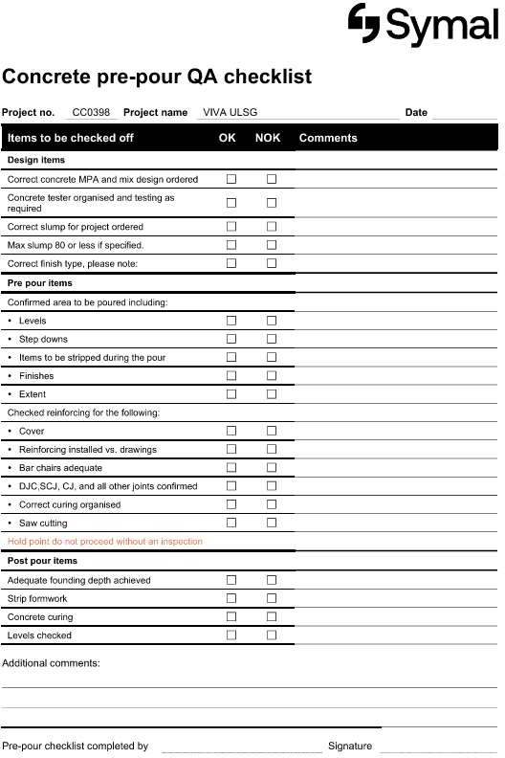

This document is uncontrolled when printed RevC Issue Date 13/12/2023



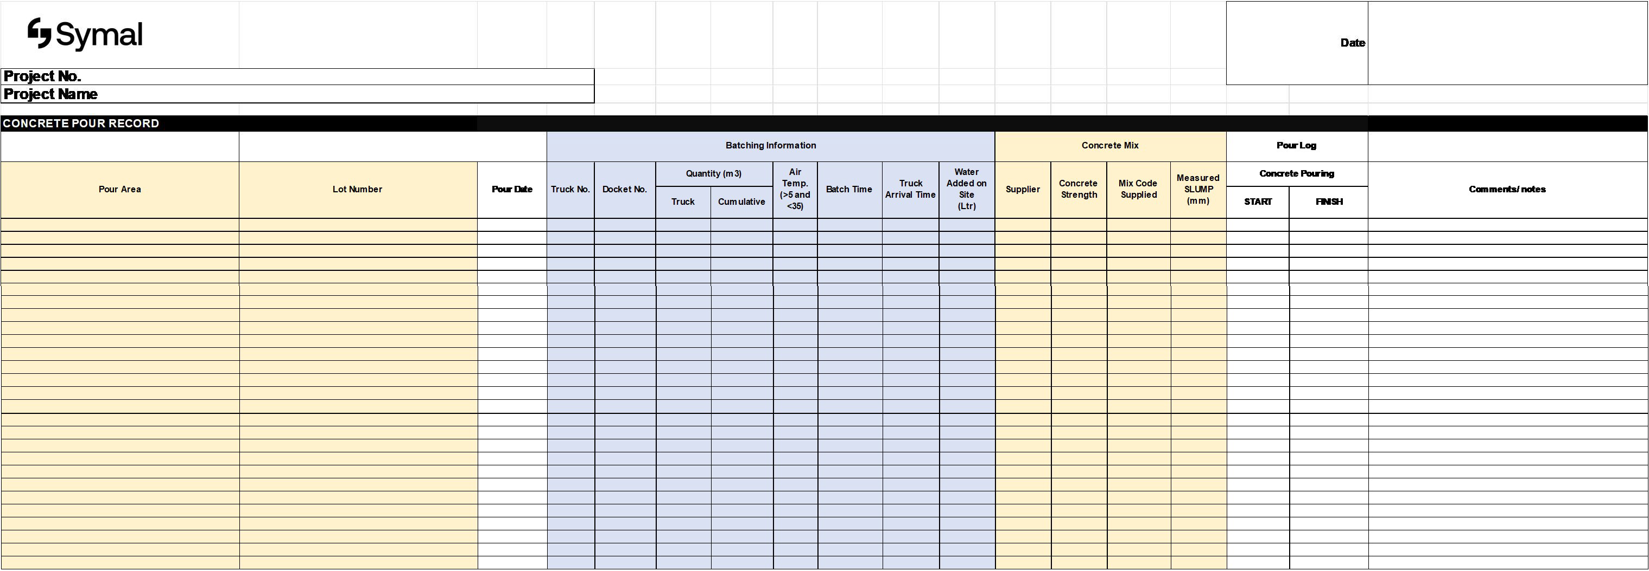

This document is uncontrolled when printed RevC Issue Date 13/12/2023 Page 1 of 10